Project Proposal

**Social Modifications**

**– A social network for people with tattoos, piercings and body modifications.**

Keith Feeney

15015556

keith.feeney@student.ncirl.ie

BSc (Hons) in Computing – Software Development

October 2018

Contents

1. Objectives 3

2. Background 3

3. Technical Approach 3

4. Special resources required 3

5. Project Plan 3

6. Technical Details 3

7. Evaluation 3

# 1. Objectives

The objective of this project is to create a social networking web application. An Android application (app) is expected to be created with the same information as the web application.

A database will be created with all the users’ profiles. This will be encrypted so the information is not public, and that only the website and app can view it.

Posts from users’ will also be available where they can upload text and media to their profile. This is similar to the likes of Facebook and Instagram.

There will also be a chat room and a messaging service for the members.

Being a social media site, the website will be targeted to people over the age of 18.

Along with this, there will be chat bot that will be built from scratch. The chat bot will be able to assist users in information on the likes of tattoo and piercing aftercare, or with help on the website/app. Also, because people who are heavily modified often get abuse that could affect their mental health, the chat bot will also be able to assist the user in getting mental health treatment if they so wish to do so, or to simply be an upbeat, positive “person” to talk to.

The website will also learn what the user likes and dislikes and will show suggested connections based on this.

The standard Web design coding such as HTML, CSS, XML, will be used along with SQL and Ruby on Rails. Node.js and Python will be used to create the chat bot.

# 2. Background

The idea was born in early 2018 when I was on a site called Inked-Up.com. This site is specifically for men-for-men people with body modifications. I felt this was too direct of a niche. As well as the site is not incredibly popular, there must be something wrong with it.

After extensivly using the site myself to see how it all worked, I felt it was bogged down with a lot of rules and people just really didn’t seem to care about it. It seemed like it was more of a platform like Tumblr where nudity was allowed and it felt more restricted. In the sense, one would not want children to know about these sites.

Firstly, I wanted to create a mobile application to not be in direct competetion with the Inked-Up.com website. But after talking to my tattooed and pierced friends, not many had heard about Inked-Up.com or didn’t like how “adult” it seemed or how it was directed at men-for-men as it felt more like a dating site instead of a social networking site. I wanted to create a website for people with tattoos and piercings that grandparents would be comfrotable with, knowing their grandkids where on this site, and to be inclusive of everyone.

I want a social networking site where everyone is welcome. Seemingly, the likes of Facebook, Instagram, Twitter, Tumblr and Flickr all have their own niche audienience and users. Why does it seem like tattooed and pierced people need to use a combination of these to be socialable?

With that, the idea of Social Modifications was born. The one thing that these companies do not have is a chat bot for their site. Facebook allows chat bots for companies, but Facebook, itself, does not have one. With the likes of Siri and Google Assistant seemingly becoming more popular, why does the likes of Instagram not use a chat bot instead of a very difficult-to-navigate help section? This is something I would like to address.

# 3. Technical Approach

In order to do this project, I will need to complete the Requirements Specifications. Based on previous projects, it’s best to set goals now and in the requirements, than trying to fix them at a later stage. Over the next few weeks, I will begin creating the prototype and preparing for the Mid-Point Presentation and then further develop this after.

For version control, I will be using GitHub and Git Bash (https://github.com/keithfeeneyNCI/SoftwareProject).

I am currently learning Python in college and I will need to take a refresher course on Node.JS. I will also need to learn Ruby on Rails. I will be using W3Schools and other resources to so this.

I will be using a mix of Kanban and Scrum (agile) methodologies as I will be able to lay out what is needed for the project, to keep myself organised and on-track, and to adjust to my supervisor’s feedback where needed.

# 4. Special resources required

I expect to be using an online service to host the database and other data. I will need to reserch on how to do this, as well as the cost. I suspect I will be using Amazon Web Services or a cheaper alternative.

# 5. Project Plan

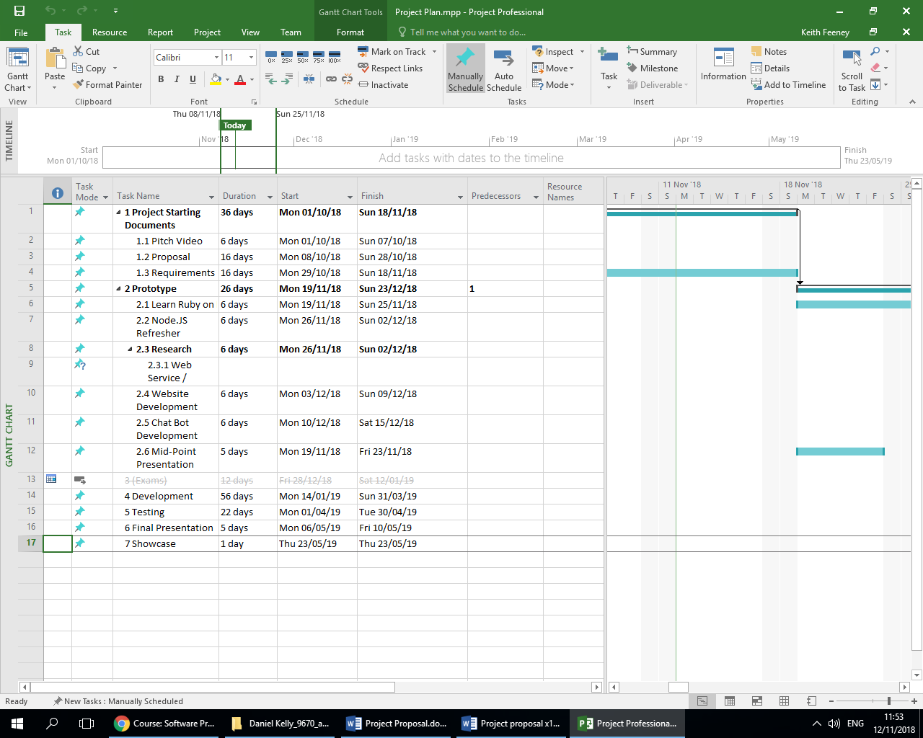

This is currently the Project Plan. This will be updated on a regular basis and especially after I complete the Requirements Specifications.

# 6. Technical Details

The standard Web design coding such as HTML, CSS, XML, JavaScript, etc., will be used along with SQL and Ruby on Rails. Node.js and Python will be used to create the chat bot. I may also use an API feature to get the data from storage.  
  
I am very familiar with web design coding and SQL coding from previous projects in college and with personal projects.

# 7. Evaluation

I will be creating a test profile on the web application and app to see how it is all working. I will also be testing out the chat bot myself by giving it phrases and checking the results are valid. I will also be doing API checks. I will also be doing JUnit testing to test how the website responds to different environments.